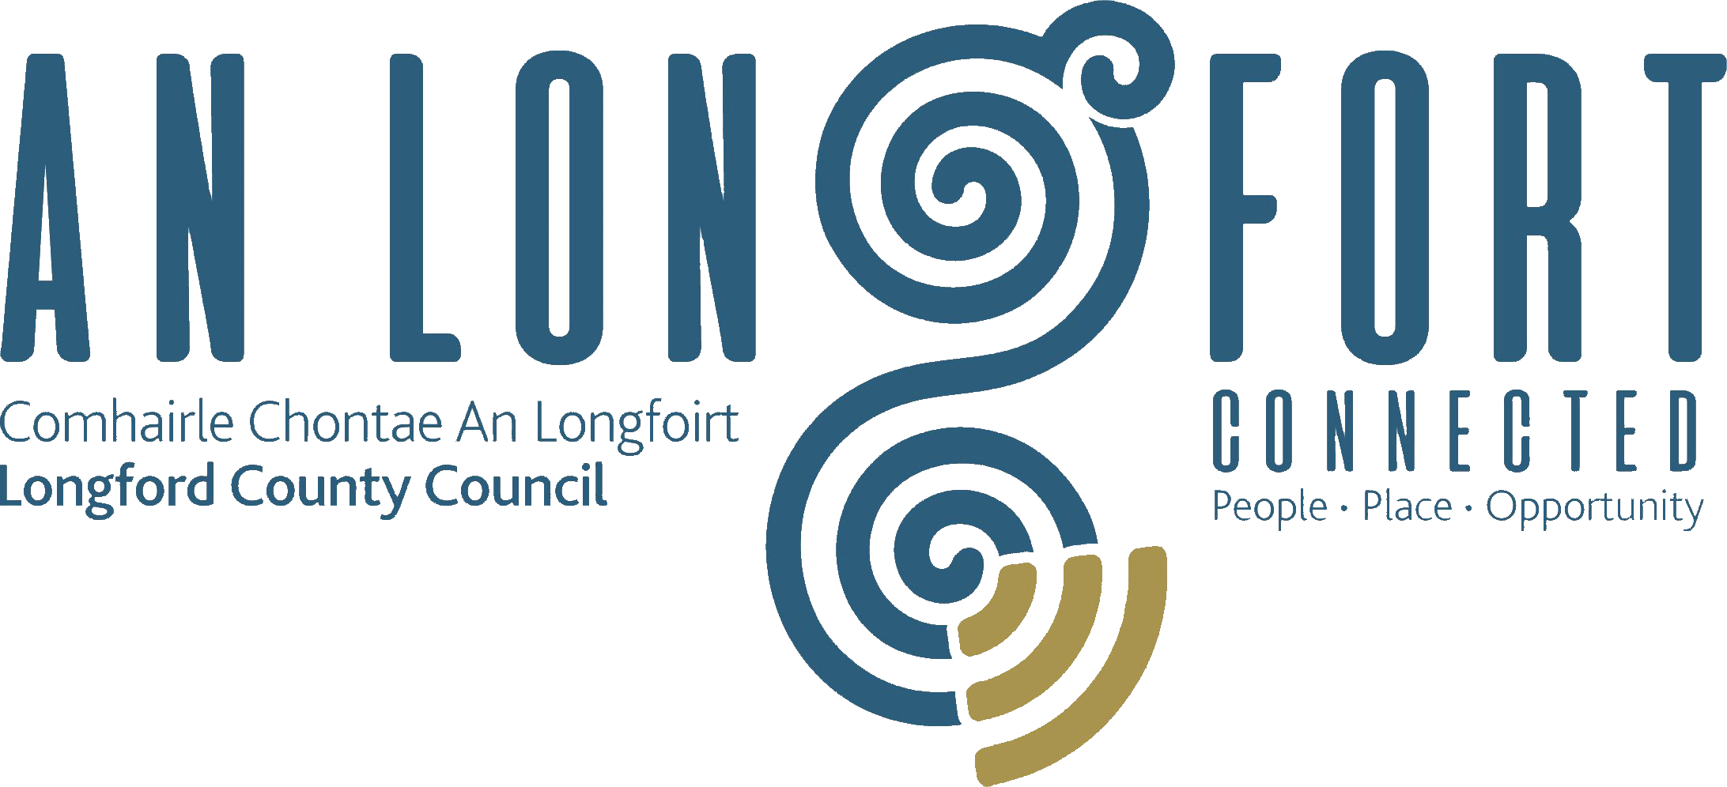

**SOCIAL DEVELOPMENT**

**STRATEGIC POLICY COMMITTEE**

**Minutes of** **Social Development Strategic Policy Committee Meeting**

**Location: Council Chamber & Microsoft Teams**

**Date: Monday, 17 February at 2:30pm**

**PRESIDING**: Councillor Padraig McNamara

**PRESENT**: Councillor Kevin Hussey, Councillor Sean Mimnagh, Maria Keelty, Noeleen McTaggart, Enda McManus, Diarmuid O’Sullivan, Niamh Donlon

**IN ATTENDANCE:**  Ms. Samanta Healy – Director of Services

Mr. Ciaran Murphy – Senior Executive Officer

Ms. Laura McHugh – Healthy Ireland Co-Ordinator

Ms. Annie Blessington – Administrative Officer

**APOLOGIES**: Councillor Paul Ross

**MEETINGS**

**ADMINISTRATOR**: Ms. Lorraine McKee

1. **INTRODUCTION**

Chairperson Councillor Padraig McNamara welcomed the members to the Social Development Strategic Policy Committee meeting.

The minutes of the meeting of the Social Development Strategic Policy Committee on 4 November 2024 were adopted by Councillor Kevin Hussey and seconded by Councillor Sean Mimnagh.

1. **DECLARATION OF INTERESTS**

No declaration of interests declared.

1. **WORK PROGRAMME**

Samantha Healy, Director of Services provided an overview of the work programme for the term of this Strategic Policy Committee. This included the following:-

* Consideration of Draft Midlands Region Homelessness Action Plan 2025-2029
* Rolling Rent Review
* Properties to be excluded from the TP Scheme
* Not Around Us Initiative
* Presentation on the Housing list ie numbers of people applying for each area , numbers currently on list , Estimated social and affordable building programme in each town /village for the next 5 years

The members discussed their observations regarding the programme of works for this committee. Ms. Samantha Healy and her Team responded to the questions raised.

1. **CONSIDERATION OF DRAFT MIDLANDS REGION HOMELESSNESS ACTION PLAN 2025-2029**

Annie Blessington, Administrative Officer in Housing made a presentation to the Committee on the Draft Midlands Region Homelessness Action Plan 2025 – 2029. The presentation included the following:-

* Introduction
* Values and Principles
* Definition of Homelessness
* Policy Context
* Homeless Dervices in the Midland Region
* Objectives and Strategic Actions
* Conclusion

On completion of the presentation Annie and Samantha responded to questions from the Committee.

1. **ROLLING RENT REVIEW**

Annie Blessington, Administrative Officer in Housing made a presentation to the Committee on the Proposed Rolling Rent Review. The presentation included the following:-

* The benefits of this approach as opposed to a global rent review every 5 years
* Approximate figures involved
* Targets
* Resources
* Administrative challenges

On completion of the presentation Annie and Samantha responded to questions from the Committee.

1. **PROPERTIES TO BE EXCLUDED FROM THE TP SCHEME**

Annie Blessington, Administrative Officer in Housing made a presentation to the Committee on the Proposed Tenant (Incremental) Purchase Scheme 2016. The presentation included the following:-

* Houses which will not be considered for sale under the Tenant Purchase Scheme
* Houses reserved by the Local Authority for particular reasons

On completion of the presentation Annie and Samantha responded to questions form the Committee.

1. **NOT AROUND US INITIATIVE**

Laura McHugh, Healthy Ireland Co-Ordinator made a presentation to the Committee ‘Not Around Us’. The presentation included the following:-

* The 4 Key Goals
* Priorities & Highlights
* Context of Not Around Us
* The Aims & Purpose
* Parks, Playgrounds and Open Spaces Byelaws
* Plan for Not Around Us Initative in Longford 2025

1. **DATE OF NEXT MEETING**

The proposed date for the next meeting of the Social Development Strategic Policy Committee is 28 April 2025 to which the members unanimously agreed.

This concluded the business of the meeting.

**Signed: ____________________**

**Lorraine McKee**

**Meetings Administrator**

**Confirmed and adopted at Social Development Strategic Policy Committee Meeting held on the 28 April 2025**

**Signed:**

**Chairperson**