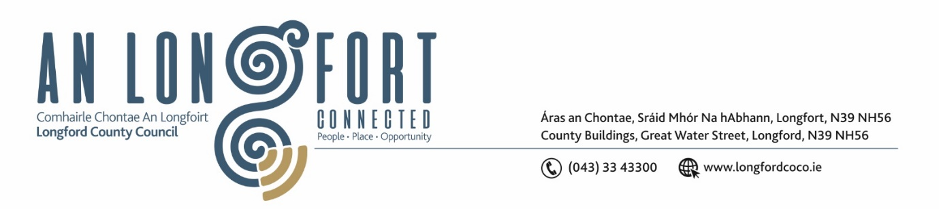
Please note meeting will be held in the Council Chamber and via Microsoft Teams.

03 Aibrean 2024

Chuig: Gach Ball don Chomhairle

A Chomhairleoir,
Iarrtar ort bheith i láthair ag Cruinniú Míosuil Chomhairle Chontae Longfoirt a tionólfar i Seomra na Comhairle, Aras an Chontae, Longford agus via MS Teams are an Chéadaoin 10ú Aibrean 2024 ag 3:30pm chun gnó a dhéanamh d’réir an Chláir thíos.
You are requested to attend the Monthly Meeting of Longford County Council to be held in the Council Chamber and via Microsoft Teams on Wednesday 10 April 2024 at 3:30pm to transact business, as set out on the Agenda hereunder.

Mise le meas,

__________________
Claire McNabola
Meetings Administrator.

C L Á R

Prayer before meeting.
Presentation from Music Generation
- Confirmation of Minutes:
- Monthly meeting of Longford County Council held on 20 March 2024 – enclosed
- Matters Arising.

- Declaration of Interest by Members.

- To note Management Report – to follow.

5. To note adopted Minutes of Corporate Policy Group Meeting held on the
20 March – enclosed.

6. Community, Library and Cultural Services, Corporate and Human Resources
(a) National Famine Commemoration 2024

(b) Consideration of draft Bylaws – Parks, Playgrounds and Open Spaces 2024

(c) 2024 Cathaoirleach Awards

(d) Approval to the appointment of Ms Eileen Mc Ardle, nominee of Longford Public Participation Network as a member of Longford Local Community Development Committee (LCDC).

7. Infrastructure, Climate Action and Innovation
(a) Notice of Motions, submitted, as listed hereunder
Notice of Motions submitted by Cllr Garry Murtagh
Calling on Longford Co Council to write to the Minister for Housing Local Government & Heritage Darragh O Brien with responsibility for water services, regarding the despicable and deliberate removal of capital funding to private water groups, thus constricting their ability to provide a service to its members, inevitably forcing them to be consumed via an inter connection to Uisce Eireann network as indicated by the department, as is the case regarding the 2 private group water schemes in the north and south of county Longford
8. Enterprise and Ukrainian Humanitarian Response
9. Finance and Information Technology
10. Housing, Planning, Regeneration & Capital Projects
(a) Notice of Motions, submitted, as listed hereunder
Councillor Paraic Brady
That Longford County Council publish the envisaged number of houses that are proposed for social housing in each municipal area for 2024 and 2025 including a breakdown of housing waiting lists and how many social housing applications have been received to date. Also, to include have we a housing scheme to look after people with disabilities, ie independent living.
In addition, regarding details of lands owned by Longford County Council.

11. General
Notice of Motions submitted by Cllr Garry Murtagh
(i)Calling on Longford Co. Council to write to the Minister of Education Norma Foley with the responsibility for school transport, while I welcome and thank the Minister for the much-needed review and report on the School Transport system, I feel the timeline indicated to implement the recommendations, is slow moving.
I ask the minister that County Longford be used as a pilot programme, due to its geographical size, the size of population and notably a rural county. That sufficient funds to support the logistics necessary to provide transport to every child as outlined in the report, be made available. Furthermore, I invite the Minister and her officials to meet with the elected representatives of county Longford to address the issues on the ground and discuss adequate solutions for the same.

(ii). Calling on Longford Co, Council To write to the Minister of Health Stephen Donnelly regarding
The retention and support of our nurses. That they should have available to them, the same Health care support as other front-line staff. To implement a similar scheme as, (or to be included in) the St. Paul's Garda medical aid society
12. Correspondence
Correspondence received from Minister Darragh O’Brien’s office in relation to “section 48” development contributions and the refunding of Uisce Éireann water and waste water connection charges

12. Votes of Sympathy

