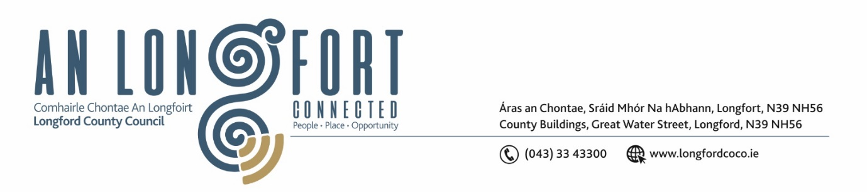

Please note meeting will be held in the Council Chamber and via Microsoft Teams.

13 Márta 2024

Chuig: Gach Ball don Chomhairle

A Chomhairleoir,

Iarrtar ort bheith i láthair ag Cruinniú Míosuil Chomhairle Chontae Longfoirt a tionólfar i Seomra na Comhairle, Aras an Chontae, Longford agus via MS Teams are an Chéadaoin 20ú Márta 2024 ag 4pm chun gnó a dhéanamh d’réir an Chláir thíos.

You are requested to attend the Monthly Meeting of Longford County Council to be held in the Council Chamber and via Microsoft Teams on Wednesday 20 March 2024 at 4pm to transact business, as set out on the Agenda hereunder.

Mise le meas,

__________________
Claire McNabola
Meetings Administrator.

C L Á R

Prayer before meeting.

- Confirmation of Minutes:
- Monthly meeting of Longford County Council held on 14 February 2024 – enclosed

- Matters Arising.

3. Declaration of Interest by Members.

- To note Management Report – to follow.

5. To note adopted Minutes of Corporate Policy Group Meeting held on the
16 January 2024 – enclosed.

6. Finance and Information Technology
- To approve the raising of a loan of €2,330,000 from the Housing Finance Agency to finance approved Local Authority Housing Loan applications, as authorised by the Housing Acts;

- Capital Budget 2024 – 2026;

- Increased Cost of Business (ICOB) Grant.

7. Housing, Planning, Regeneration & Capital Projects
- Consideration of disposal of Property at 21 Chapel Lane, Longford Town, Co Longford, in accordance with the terms of Section 183 of the Local Government Act 2001 issued on the 28 February 2024 – as circulated

- Consideration of disposal of Property at 4 Church Street, Edgeworthstown, Co Longford, in accordance with the terms of Section 183 of the Local Government Act 2001 issued on the 28 February 2024 – as circulated

10. Community, Library and Cultural Services, Corporate and Human Resources
- Consideration of Intercultural Grants under the Community Grant Support Scheme 2024

- Approval to the appointment of the following as members of Longford Local Community Development Committee (LCDC), who have been nominated to replace outgoing members –

- Mr. Fulton Grant, nominee of Longford Chamber of Commerce/Business Pillar
- Mr. Enda Mc Manus, nominee of County Longford Public Participation Network

- Consideration and adoption of Draft Annual Report 2023

- Civic Reception Proposal

- Notice of Motions, submitted by Councillors, as listed hereunder

- Councillor Seamus Butler
That Longford Co Co provides the resources to enable a door to door check of all the existing premises with listed electors, especially but not exclusively, in the Longford Town area to ensure that some blatant inaccuracies can be corrected. This should be put in place as a matter of urgency to be effective before the forthcoming Local Elections

- Councillor Garry Murtagh
I am calling on Longford Co. Council to hold a civic reception for Community of Aughnacliffe winners for All Island All Ireland Pride of Place winners 2023.

11. General

- Notice of Motions, submitted by Councillors, as listed hereunder

Councillor Paul Ross
That Longford County Council recognises the significant contribution that farming and the Agri-sector make to the Irish and local economy. The council acknowledges the income challenge on Irish farmers arising from the significant increases in the cost of doing business, regulatory costs, and cuts in Basic Income support for farmers.
The Council calls on the government to introduce no further regulations on farmers or any other measures that may increase costs on farms without full negotiation and agreement with the IFA. The council calls on the European Union and the Irish Government to provide additional stand-alone funding, separate to the Common Agricultural Policy, To support farmers to undertake climate and biodiversity measures.’
Councillor Paraic Brady & Councillor Mick Cahill

We call on Longford County Council to write to Minister Darragh O Brien to seek an extension to the waiver in place currently on Development Contributions which is due to cease on 24th April

11. Correspondence
- Correspondence received from Minister for Agriculture, Food and the Marine re. Suckler Carbon Efficiency Programme (SCEP) – enclosed.

12. Votes of Sympathy

