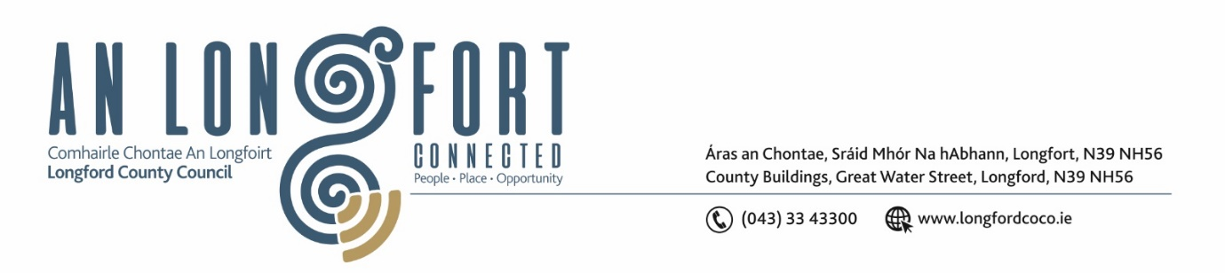
Please note meeting will be held in the Council Chamber and via Microsoft Teams.

1 May 2024

Chuig: Gach Ball don Chomhairle

A Chomhairleoir,
Iarrtar ort bheith i láthair ag Cruinniú Míosuil Chomhairle Chontae Longfoirt a tionólfar i Seomra na Comhairle, Aras an Chontae, Longford agus via MS Teams are an Chéadaoin 8 Bealtaine 2024 ag 4pm chun gnó a dhéanamh d’réir an Chláir thíos.
You are requested to attend the Monthly Meeting of Longford County Council to be held in the Council Chamber and via Microsoft Teams on Wednesday 8 May 2024 at 4pm to transact business, as set out on the Agenda hereunder.

Mise le meas,

__________________
Claire McNabola
Meetings Administrator
C L Á R

Prayer before meeting.

- Confirmation of Minutes:
- Monthly meeting of Longford County Council held on 20 March 2024 – enclosed

- Matters Arising.

- Declaration of Interest by Members.

- To note Management Report – to follow.

5. To note adopted Minutes of Corporate Policy Group Meeting held on the
19 March – enclosed.

6. Housing, Planning, Regeneration & Capital Projects
- Consideration of disposal of property at Deanscurragh, Longford, in accordance with the terms of Section 183 of the Local Government Act 2001 issued on the 28 February 2024 – as circulated

7. Community, Library and Cultural Services, Corporate and Human Resources
(a) National Famine Commemoration 2024
(b) Polling Information Cards

8. Infrastructure, Climate Action & Innovation
(a) Notice of Motions set out hereunder
Councillor Gerard Farrell
I call on Longford County Council to look at the possibility of erecting bus shelters in towns and villages for travellers using the very successful local link

8. Enterprise and Ukrainian Humanitarian Response
(a) Notice of Motions set out hereunder
Councillor Garry Murtagh and Councillor John Browne
We are calling on members of Longford to write to the Taoiseach Simon Harris & the Minister for Enterprise, Trade and Employment Peter Burke, to incentive businesses in small rural Villages such as shops, fuel stations, Pubs etc. supporting them into finically viable, sustainable, and sought-after business, by means of making them Tax exempt on a percentage of their annual turnover.
Thus, preserving the survival of small villages, the fabric of rural life and putting an end to ghost villages where vacant premises have been left to crumble or in more recent times turned into accommodation.

9. Finance and Information Technology
- Consideration of Annual Financial Statement for Year ended 31st December 2023 – enclosed
- Consideration of Approval of Additional Expenditure under S104(7) of the Local Government Act 2001.
- To note 2023 Audit Committee Annual Report – enclosed

10. General
(i) Notice of Motions
Councillor Gerard Farrell
- That Longford County council seek a meeting with ESB to set out a road map for future for the Lough Ree power site in Lanesboro.

- That Longford County Council request a meeting with Bord Na Mona to discuss future plans for Mount Dillon workshop and office space in Lanesboro. This facility has great potential to become an apprenticeship college and must be kept within the Community.

Councillor Paul Ross & Councillor Peggy Nolan
- We call on the HSE to put measures in place to ensure the future viability of St Christophers Services Longford

11. Correspondence
(i) Correspondence received from ESB
(ii) Correspondence received from Minister Darragh O’Brien

12. Votes of Sympathy

13. Date of next meeting

