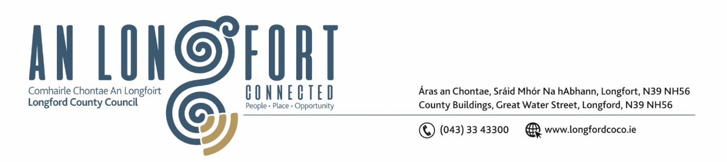

Minutes of Meeting of Longford County Council
held in the Council Chamber and via Microsoft Teams on
Wednesday, 14 February 2024 at 4pm
__________________________________________________________________

PRESIDING: Councillor Paul Ross

MEMBERS PRESENT: Councillors – John Browne, Seamus Butler, Mick Cahill, Colin Dalton, Gerry Hagan, Pat O’Toole, Garry Murtagh, Peggy Nolan, Gerard Farrell, Uruemu Adejinmi, Martin Monaghan, Mark Casey, PJ Reilly, Gerry Warnock, Turlough McGovern, and Paraic Brady

IN ATTENDANCE: Mr. Paddy Mahon, Chief Executive
Ms. Barbara Heslin, Director of Services
Ms. Samantha Healy, Director of Services
Mr. John Brannigan, Director of Services
Mr. Michael Nevin, A/Director of Services
Mr. John McKeon, Head of Finance/Director of Services

APOLOGIES: Councillor Colm Murray

MEETINGS
ADMINISTRATOR: Ms. Claire McNabola

SUSPENSION OF STANDING ORDERS
In accordance with Standing Orders, on the proposal of Councillor Peggy Nolan and seconded by Councillor Mark Casey it was agreed that Councillor Paul Ross to chair meeting the meeting in the absence of Cathaoirleach Councillor Colm Murray and Leas Cathaoirleach Garry Murtagh.

- ADOPTION OF MINUTES

- On the proposal of Councillor Mick Cahill seconded by Councillor Pat O’Toole the Minutes of Monthly Meeting of Longford County Council held on the 17 January 2024, as circulated, were confirmed, and adopted.

- MATTERS ARISING FROM MINUTES
None
- DECLARATION OF INTEREST BY MEMBERS
None.

- CHIEF EXECUTIVE REPORT
The Chief Executive Report for January 2024 was noted.

Councillor Peggy Nolan requested the Executive engage directly with HSE, this was seconded by Councillor Pat O’Toole, it was agreed to write to the newly appointed CEO Bernard Gloster. Councillor PJ Reilly confirmed members on HSE committee will be attending meeting next week.

Councillor Turlough McGovern requested update on Granard Motte for next meeting. Director Of Service John Brannigan replied to advise that Longford County Council are waiting on Motte committee to come back with a proposed meeting date.

- MINUTES OF CORPORATE POLICY GROUP MEETING HELD ON THE 12 DECEMBER 2023 – AS CIRCULATED
The adopted Minutes of Corporate Policy Group Meeting held on the 12 December 2023, as circulated, were noted.

- HOUSING, PLANNING, REGENERATION AND CAPITAL PROJECTS

- Part VIII No. 114 – Ballinalee Community Park & Children's Playground, Ballinalee or Saint Johnstown, Co. Longford - Report in accordance with Section 179 of the Planning and Development Act 2000 (as amended) and Part 8 of the Planning & Development Regulations 2001 (as amended) – as circulated
On the proposal of Councillor Colin Dalton seconded by Councillor Uruemu Adejinmi, the members unanimously agreed to approve the Part VIII application in accordance with Section 179 of the Planning and Development Act 2000 (as amended) and Part 8 of the Planning & Development Regulations 2001 (as amended).

- COMMUNITY, LIBRARY AND CULTURAL SERVICES, CORPORATE AND HUMAN RESOURCES

- Deadline for return of Annual Ethics Declaration
Director of Services Barbara Heslin reminded the members that the deadline for return of Annual Ethics Declarations is Thursday 29 February 2024.

- Corporate Plan 2024-2029

Barbara Heslin provided an outline of the proposed approach to the development of the new Corporate Plan 2024 -2029. The plan for the development of the new Corporate Plan was agreed by the Management Team in December 2023.

The new Corporate Plan must be adopted within 6 months of the Council AGM. Longford County Council are working on developing an online Public Consultation Tool for the Plan, Longford are the first County to exercise this. The CPG agreed at their meeting that the Corporate Plan 2024 -2029 would remain on their agenda to facilitate keeping the Members informed on progress.

In addition to the online public consultation portal, Longford County Council is planning to develop a number of short videos to include excerpts from Cathaoirleach, CE and DoS outlining services and responsibilities that lie with the local authority.

The review and monitoring process for the current Corporate Plan and Service Deliver Plan will continue until the adoption of the new plan.

- INFRASTRUCTURE, CLIMATE ACTION & INNOVATION

- Consideration of Draft Climate Action Plan – as circulated.
Bernard Shea presented the members with an update on the submission received following the public consultation on the Draft Climate Action Plan.
On the proposal of Councillor Gerry Warnock, seconded by Councillor John Browne, the Longford County Council Draft Climate Action Plan 2024-2029 was adopted.
Chief Executive Paddy Mahon acknowledged the significant work that has gone into the development of the Climate Action Plan by the Elected Members, stakeholders, Senior Management Team, Climate Action and Environment Teams and all staff.
Paddy Mahon outlined how it was a practical and ambitious Plan and that Longford County Council are playing their part by adopting the plan today.
- Notice of Motions, submitted by Councillors, as listed hereunder.

Notice of Motion proposed by Councillor Paul Ross and seconded by Councillor Paraic Brady
I call on the Minister for the Environment, Climate and Communications to introduce a fixed electricity standing charge for all suppliers and to allow the Energy regulator to have the decision on electricity standing charges. The current system sees a wide variation in standing charges and is not a fair system to consumers and leads to confusion and more expensive costs to households.
Response
It was agreed that a letter will be sent to the Minister for the Environment, Climate and Communications.

- CONFIRMATION OF DATE FOR MARCH MEETING
On the proposal of Councillor Martin Monaghan, seconded by Councillor Pat O’Toole, the members agree the March meeting would take place on Wednesday 20 March 2024.

- VOTES OF SYMPATHY

The Members of Longford County Council offered their sympathies to the families and friends of Seamus Flynn, The Green, Lanesboro, Co. Longford RIP.

Signed: _______________________
Claire McNabola
Meetings Administrator

Confirmed and adopted at Meeting of Longford County Council held on the 20 March 2024.

Signed: _______________
Cathaoirleach

