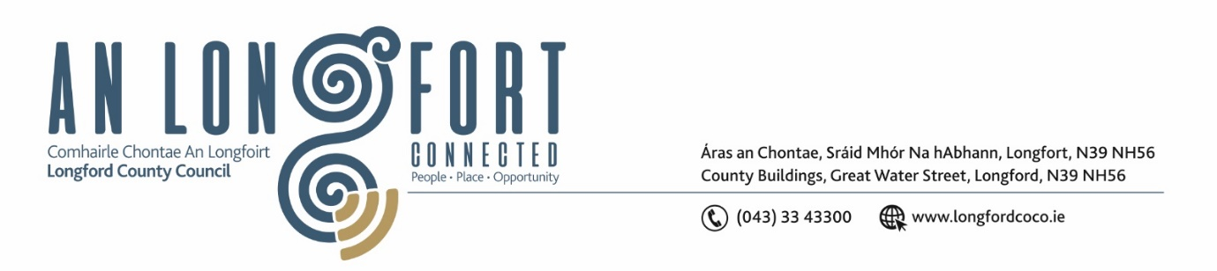
Please note meeting will be held in the Council Chamber and via Microsoft Teams.

5 November 2025

Chuig: Gach Ball don Chomhairle

A Chomhairleoir,
Iarrtar ort bheith i láthair ag Cruinniú Míosuil Chomhairle Chontae Longfoirt a tionólfar i Seomra na Comhairle, Aras an Chontae, Longford agus via MS Teams are an De Cheadaoin 12 Samhain 2025 ag 3.30pm chun gnó a dhéanamh d’réir an Chláir thíos.
You are requested to attend the Monthly Meeting of Longford County Council to be held in the Council Chamber and via Microsoft Teams on Wednesday, 12 November at 3.30pm to transact business, as set out on the Agenda hereunder.

Mise le meas,
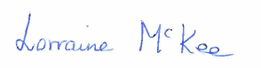
__________________________
Lorraine McKee
Meetings Administrator

C L Á R
Presentation by Longford Comhairle na nÓg

Prayer before meeting.

- Confirmation of Minutes
- Monthly meeting of Longford County Council held on 8 October 2025 – enclosed.
- Committee meeting of Longford County Council held on 24 October 2025 – enclosed.

- Matters Arising

- Declaration of Interest by Members

- To note Management Report

- To note adopted Minutes of Corporate Policy Group Meeting held on 10 September 2025 – enclosed

- Physical Development

- To note planning applications received
- Proposed changes to the Council’s Development Contribution Scheme 2023 – 2027 – enclosed
- County Longford Phase 2 Road Safety Action Plan 2025 – 2027
- Traffic Calming Policy
- Draft Casual Trading Bye Laws
- Phase 2 Speed Limit Review
- Notice of Motions
Councillor Uruemu Adejinmi
I call on Longford County Council, in preparing the forthcoming County Development Plan, to ensure that appropriate land is zoned specifically for health and community care purposes - including the development of Primary Care Centres, community diagnostic hubs and other health-related facilities - in line with the principles of Sláintecare and integrated healthcare delivery.
This zoning should:
- Facilitate the planning and development of accessible, community-based healthcare infrastructure across the county;
- Support co-location of multidisciplinary health and social care services within population centres; and
- Ensure future population growth areas are adequately served by healthcare infrastructure."

Councillor Paul Ross
I call on Longford co Council to put a more robust measure in place to prevent unauthorised developments who are blatantly ignoring planning laws and enforcement notices that have been sent out.
I propose that these illegal sites be closed off with concrete bollards as soon as they are reported to prevent works continuing.

- Finance, Innovation and Information Technology

- Minutes of the Governance SPC meeting held on Tuesday 21st October 2025

- Social Development

- Section 183 Notice – 10 Golf View, Glack, Co. Longford.
- Section 183 Notice – Bawn Mountain, Moydow, Co. Longford.
- Section 183 Notice – 1 Canal View, Longford.
- Section 183 Notice - disposal of (partial) site at Legga, Moyne, Co. Longford to Dromard GAA.
- Notice of Motions
Councillor Sean Mimnagh
I call on Longford County Council for a review of the current maintenance and upkeep schedules for all playgrounds throughout County Longford.
The review should include but not be limited to, grass cutting, hedge trimming and power washing, to ensure that all facilities are maintained to a high standard, providing safe, clean, and welcoming environments for children and families across the county.
Regular maintenance ensures these spaces remain safe and visually appealing and accessible to all users.
Councillor Gerry Hagan
I call on Longford County Council, that Longford County Councils Housing Department will not purchase any further Commercial Premises on the Main Street of Longford Town or any other town or village throughout our county of Longford, for the purpose of providing social housing units. I also wish to include the Approved Housing Bodies in this regard.
With regard to Longford Town Centre, there is already a significant number of social housing units in this immediate area, and there is no evidence to suggest there is a current local demand that is not being met by existing provisions in the CBD of our Administrative capital of our county.
Also, the conversion of these business, will lead to disruption for existing businesses in the form of increased noise, traffic and parking issues, coupled with an expected increase in anti-social behaviour & drug abuse on the Main Street of our town.

- Economic Development
- Notice of Motions
Councillor Uruemu Adejinmi
I call on Longford County Council to commit to ensuring that all official press releases, publications and public communications - including photographs and media materials - reflect the principles of equality, diversity and inclusion.
- In particular, that Council communications and imagery will endeavour to represent the diversity of our community in terms of gender, age, ethnicity and ability/disability and
- These standards be incorporated into the Council’s communications policy and applied consistently across all departments and in partnership projects.

This motion aims to ensure that Council communications authentically reflect the diverse community we serve and promote inclusive representation in all public materials going forward.

- General
Notice of Motions

Councillor Mark Casey
I call on Longford County Council to write to the Minister for Health and ask them to reverse the decision of the OAP’s having to pay for their blister packs of medication from the 1st of January 2025.
This will cause yet another form of hardship to our older people and may lead to confusion around which medication to take.

- Correspondence

- Correspondence from Roscommon County Council regarding Maternity Services at Portiuncula University Hospital
- Correspondence from Roscommon County Council regarding Development Contribution Waiver Scheme
- Correspondence from Galway City Council
- Correspondence from Wexford County Council regarding Inheritance Tax
- Correspondence from Wexford County Council regarding Stouts Law

- Training for Approval

- Votes of Sympathy

- Date and time of next meeting

