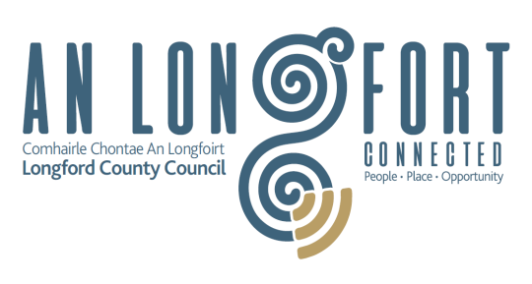
Longford County Council

Community Grants Application Form 2021

Name of Community Group:
Tax or Charitable Status No.
Contact Name and Position:
Address:
Phone Number:
Email:
Title of Project/Activity:
Description of Project/Activity:
Objectives of Project/Activity:
Amount of Funds Sought:

Is your group/organisation affiliated to Longford Public Participation Network?

Yes No

(If not, please request affiliation form by emailing publicparticipationnetwork@longfordcoco.ie or phoning 087-2615583)

Bank/Credit Union details for electronic payment to Group:

Account Name:
Account Number:
Sort Code:
IBAN
BIC/SWIFT CODE

You must attach a copy of the top of your bank statement showing your name and account number.

Purpose – the need you are meeting

__________________________________________________________________________________________________________________________________________________________________________________________________________________________________________________________________________________________________________________________________________________________________________________________________________________________________________________________________________________________________________________________________________

Clear description - what will be delivered and how

__________________________________________________________________________________________________________________________________________________________________________________________________________________________________________________________________________________________________________________________________________________________________________________________________________________________________________________________________________________________________________________________________________

Realistic budget – how grant would be spent

__________________________________________________________________________________________________________________________________________________________________________________________________________________________________________________________________________________________________________________________________________________________________________________________________________________________________________________________________________________________________________________________________________

Other Sources of funding – detail source, amount and if approved or pending

_________________________________________________________________________________________________________________________________________________________________________________________________________________________________________________________________________________________________________________________________________________________________________________________________________________________________________________________________________________________________________________________________________

Please select one or more of the following values objectives that your project would make a contribution to achieving, and, briefly set out how it will do so. (Dignity, Democracy, Inclusion and Social Justice)

___________________________________________________________________________

___________________________________________________________________________

__________________________________________________________________________

__________________________________________________________________________

__________________________________________________________________________

In order to process your application, it may be necessary for Longford County Council to collect personal data from you. Such information will be processed in line with the Local Authority’s privacy statement which is available to view on Privacy-Statement or contact our Data Protection & Information Compliance Officer on 043 33 44207 or email dpo@longfordcoco.ie.

Declaration

We have read and understood the information and criteria applicable to this grant scheme and agree to comply in full therewith. I/we certify that all information provided in this application and all information given in any documentation submitted in support of the application is truthful and accurate.

The application must be signed by 2 members of the group one of which must be the Chairperson, Secretary or Treasurer.

Signed: ____________________ Date: ____________________

Name: ____________________ Position: ____________________
(block capitals) (in organisation)

Signed: ____________________ Date: ____________________

Name: ____________________ Position: ____________________
(block capitals) (in organisation)

For Official Use Only: | Date:
Date of resolution of ________________ Municipal District or Corporate Policy Group | _______________

