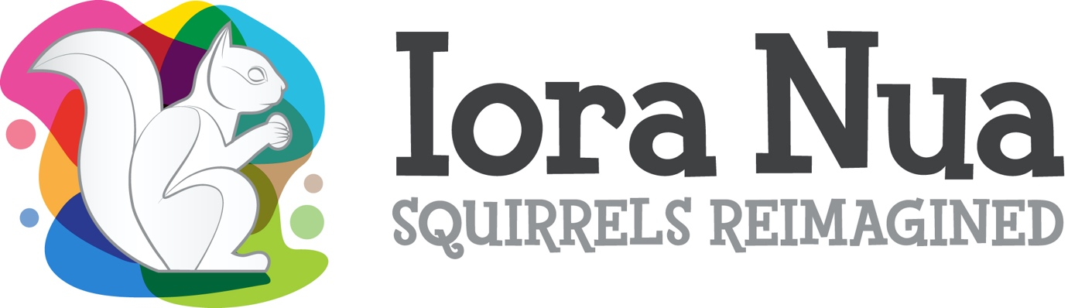
Longford Live & Local Winter Programme, in partnership with Longford Arts Office & Mide Arts Group, invite artist(s) to submit proposals for Iora Nua, a public art place-making project in County Longford. Iora Nua (Squirrels Reimagined), is a temporary public art project involving the placement of large-scale fibreglass squirrel sculptures in public locations across Longford’s three municipal districts. Longford-based artists are invited to submit proposals for the design and rendering of the sculptures’ surfaces.
Selected artists will be given a financial grant to cover their time, materials and venue rental in order to render their design on the sculpture. Finished works will be placed at designated sites in Longford Town, Ballymahon and Granard. Artists can only apply for one sculpure.
Proposals are welcome from both individuals and collaborative artistic teams. The award grant is €4,000. This fee is inclusive of all materials, space rental, and equipment required to design and render the finished artwork.
This project is part of Longford County Council’s Public Art Programme, funded by Longford Arts Office, the Creative Ireland programme and the Department of Tourism, Culture, Arts, Gaeltacht, Sport and Media.

ARTISTS’ BRIEF
Submit your idea for a Reimagined Squirrel or ‘Iora Nua’ in the form of surface decoration design for a large-scale squirrel sculpture, see the accompanying Iora Nua-Template.pdf. Your concept should engage the community and visitors and help foster a sense of place. Successful artists will be provided with one of three ‘Iora Nua’ Squirrel sculptures as a ‘canvas’ to work on. The modular units are hollow, cast polyester resin and fiberglass forms.
- Each unit is approximately 65kg in weight; 1.5m wide x 2m long x 2.5m high.
- Each squirrel will be supplied with a suitably primed surface.
- Rendering materials: Acrylic paints or high gloss exterior paints are suitable but should contain the highest level of UV resistance possible to avoid excess fading for the duration of the outdoor display (4 years). A final hard lacquer finish will be applied to all squirrels by the Iora Nua installation team to best protect the surface.
- The Iora Nua project will be responsible for siting works.
- The artist retains intellectual property rights to the design.
- Each proposal should contain the imagined design applied to the forms (front and one side elevation) as shown on the accompanying Iora Nua-Template.pdf.
- Images should be as JPEG, GIFF, TIFF or PNG formats, to a maximum of 5 images.
SUBMISSION PROCESS
Closing date for receipt of submissions for Stage 1 is Monday 31st January 2022. Please ensure you include all the submission details as listed below. Submissions should be by email only and must contain:
Submission Details:
- Contact Details: Name, postal address, email address and phone number of the artist or team leader.
- Title of Proposal.
- Summary of Proposal: One line which describes what you want to do, why and how it is related to your practice (approx. 50 – 100 words).
- Scaled drawing of proposed design showing front and side elevation. See the accompanying Iora Nua-Template.pdf.
- Summary Description: Outline of your proposed project (max 500 words).
- Approach to community engagement and involvement.
- Outline of how the project could be best achieved/presented.
- An up-to-date and relevant C.V.
- Examples of recent relevant work (artist website, web links or e-file).
- Draft budget outlining broadly the artist’s fees, development and production costs.
- Applicants must stipulate which municipal district they intend to site the sculpture (Longford, Granard or Ballymahon).

Presentation video:
The following link illustrates the general aim of the Iora Nua project and captures the existing protype (currently installed in Longford County Council Offices):
https://www.youtube.com/watch?v=hAi55GuRhBQ

Selection Panel:
The selection panel will consist of independent arts expertise, a Longford County Council official and Mide Community Arts group representation. Successful applicants will be contacted 14th February.
Submission Deadline: 5pm, Monday 31st January. Submission by email only.
Contact information:
Shane Crossan – Project Coordinator – Mide Arts Group.
Email: Crossan.shane@gmail.com



