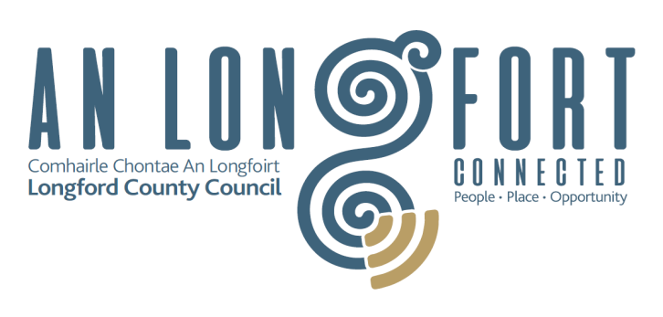
Longford County Council
Community Grant Support Scheme 2021
Overview
Longford County Council, through the Municipal Districts, is committed to working in partnership with the community to encourage, develop, support and sustain a wide range of activities/projects (eg recreational, artistic, cultural, social and community support and business group initiatives) that
- Make a positive contribution to County Longford
- Promote the development of strong local communities
- Improve the quality of life of our citizens.
Longford County Council, as a member of the Local Community Development Committee, is committed to the values of dignity, autonomy, democracy, inclusion, and social justice and their associated value objectives as set out in the Equality and Human Rights Statement of the Local Community Development Committee (available at www.longfordcoco.ie ).
The Community Grant Support Scheme provides a means for decision-makers i.e. the elected members of Longford County Council and each Municipal District to consider and prioritise applications for grant assistance. Grant allocations will generally range between €250 and €1,000, subject to funding. In exceptional circumstances and at the discretion of the Municipal District, for projects of scale, a maximum of €2,000 may be approved.
The grants awarded under the Community Grant Support Scheme may support activities/projects under the following headings:
- Active elderly
- Arts
- Community involvement
- Environment
- Events
- Heritage
- Inter-cultural
- Sport and recreation

Exclusions
The following grant types are excluded from this grant scheme as they are co-funded by other bodies or are subject to separate applications
- Burial Grounds - maintenance
- Longford Sports Partnership grants
- Anti-litter specific projects
National Sports organisations, that support local clubs such as GAA or FAI, will not be funded under this scheme.

Terms and Conditions
- Activities/projects must benefit the local community and be promoted by Longford based not-for-profit, charitable and community and voluntary groups.
- Activities/projects should make some contribution to one or a number of the values/objectives in the Equality and Human Rights Statement of the LCDC.
- Applications must be on the 2021 form and must be signed by the Chairperson, Secretary or Treasurer of the group making the submission.
- Bank account details must be provided and must be in the name of the group.
- Groups must be affiliated to Longford Public Participation Network.
- If annual payments exceed €10,000 please attach copy of current Tax Clearance Certificate or Tax Clearance Access Number to your application.
- Salary and operational/running costs are ineligible for funding.
- The information supplied by the group must be accurate and complete - misinformation may lead to disqualification and/or the repayment of the grant.
- Applicant must have no outstanding liabilities to Longford County Council.
- Applicants must be willing to support Probation Service Initiatives.
- It is the responsibility of each group to ensure that it has proper governance, procedures and policies in place including appropriate insurance to support the proposed activity.
- If the proposed activity/project includes children or young people under 18, each group must have in place a child protection policy including a vetting procedure.
- Successful applicants for grants exceeding €1,000 will be required to submit an evaluation report on the completed activity/project funded, including evidence of expenditure, receipts, photos, etc.
- Successful applicants will be required to comply, if applicable, with all requirements in relation to Planning, Building Regulations, Health and Safety and Fire Codes.
- Longford County Council's contribution must be publicly acknowledged in all materials associated with the purpose of the grant - publications, media, etc.
- Approved applicants give permission to Longford County Council to use photographs of their funded project for publicity purposes.
- The Cathaoirleach and Elected Members of the relevant Municipal District must be invited to official openings or events where funding has been awarded under the Community Grant Support Scheme.
- Applications for retrospective grants and late applications will not be considered.
- Only one application per group (including any joint initiative) will be considered.
- Specific conditions may be attached to the grant including insurance indemnity.
- Breaches of the terms and conditions of the grant scheme may result in sanctions including disbarment from future grant applications.
- Applications will be screened centrally for adherence to the above criteria.
- Longford County Council will publish a list of all grants awarded on its website.
- In order to process your application, it may be necessary for Longford County Council to collect personal data from you. Such information will be processed in line with the Local Authority’s privacy statement which is available to view on Privacy-Statement or contact our Data Protection & Information Compliance Officer on 043 33 44207 or email dpo@longfordcoco.ie.
- The Freedom of Information Act applies to all records held by Longford County Council.
- In certain circumstances an Event Management Plan will be required. If this is required the committee should appoint an Event Controller to prepare the plan and manage the event.
Application forms must be completed in full and returned by email to commgrants@longfordcoco.ie
The closing date for applications is 26th February 2021
Applications will be considered by end of March 2021

