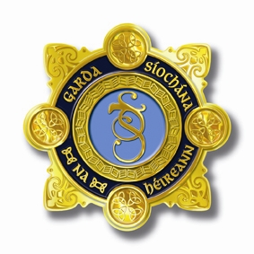
An Garda Síochána
Garda Divisional /National Youth Awards
Media Consent Form

To be completed by Parent/Legal Guardian/ Group Leader/Teacher:
I ________________________________ give consent for An Garda Síochána to release my details to the media in relation to the An Garda Síochána Divisional / National Youth Awards.
If person is under 18 years of age or signing on behalf of a group.
I _________________________________ (parent/legal guardian/group leader/teacher) on behalf of________________________________ give consent for An Garda Síochána to release my details to the media in relation to the An Garda Síochána, Divisional / National Youth Awards
Details given to the media will be; name of award winner(s), general area of residence (e.g. Granard, Co. Longford / Castlerea, Co. Roscommon), age, and information relevant to why the award winner has been chosen.
The presentation of awards at both Divisional and National level will receive media attention and will be recorded and photographed. These images/videos will also be given to the media and posted on An Garda Síochána social media accounts.
Please note: If media consent is not given, you will still receive your award, but An Garda Síochána will not be in a position to publicise you receiving same.
I _________________________________ do not give consent for An Garda Síochána to release my details to the media in relation to the An Garda Síochána Divisional/National Youth Awards.
If person is under 18 or signing on behalf of a group.
I ___________________________________ (parent/legal guardian/group leader/teacher) on behalf of ___________________________ do not give consent for An Garda Síochána to release my details to the media in relation to the An Garda Síochána Divisional/National Youth Awards.
SIGNED: _______________________________________________ DATE: ______________________

