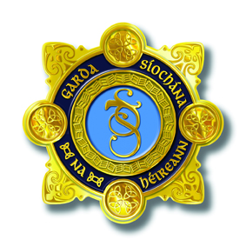

AN GARDA SÍOCHÁNA

3rd ANNUAL ROSCOMMON-LONGFORD
GARDA YOUTH AWARDS 2021

In association with
Longford & Roscommon County Councils

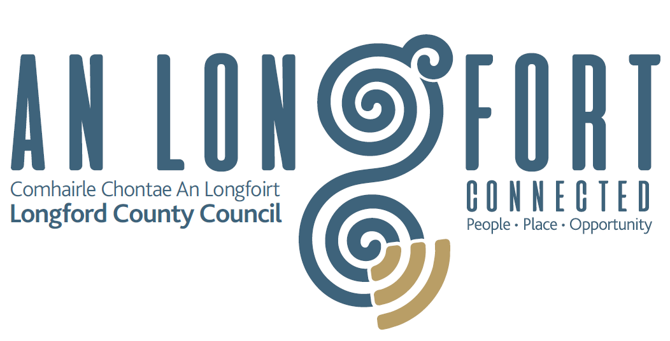

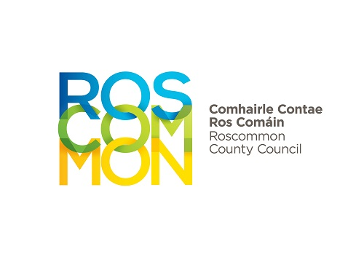

These Awards will be organised in adherence with all Government Covid-19 guidelines. Recipients will be notified by the Organising Committee following the judging in May 2021.

Inside: Details of the competition
Application form
Rules of competition
GARDA NATIONAL YOUTH AWARDS 2021

NOMINATOR DETAILS
NOMINATOR’S NAME:

ADDRESS:

TELEPHONE NO:

NAME OF CLUB / ORGANISATION / RELATIONSHIP:

EMAIL:

DETAILS OF THE INDIVIDUAL OR GROUP THAT YOU ARE NOMINATING, AND THE AWARD CATEGORY
NOMINEE’S NAME:

DATE OF BIRTH (INDIVIDUAL) / AGE RANGE (GROUP):

ADDRESS:

TELEPHONE NO:

AWARD CATEGORIES

All categories are for young people aged between 13 and 21 years.

INDIVIDUAL AWARD:
Making a positive contribution to their community, making it a better place to live.

GROUP AWARD:
Groups of 2 or more, making a positive contribution to their community, making it a better place to live.

SPECIAL ACHIEVEMENT AWARD:
Overcome difficult circumstances, defied all the odds and whose commitment deserves recognition.

COMMUNITY SAFETY AWARD:
Through a crime prevention or safety initiative / innovation, have made their community a safer place to live.

FOR INDIVIDUAL AWARD AND GROUP AWARD NOMINATIONS,
PLEASE PROVIDE DETAILS AS REQUESTED IN SECTION A.

FOR SPECIAL ACHIEVEMENT AWARD NOMINATIONS,
PLEASE PROVIDE DETAILS AS REQUESTED IN SECTION B.

FOR COMMUNITY SAFETY AWARD NOMINATIONS,
PLEASE PROVIDE DETAILS AS REQUESTED IN SECTION C.

SECTION A. INDIVIDUAL AND GROUP AWARD NOMINATIONS.

- Please outline how this young person / group has made a positive contribution to their community, making it a better place to live. (Maximum of 100 words.)

- Please outline how this young person / group has shown the spirit of volunteerism. How have they been selfless and dedicated in their actions, without expecting anything in return. (Maximum of 100 words.)

- Please describe how the young person / group has promoted a positive image of young people throughout the community. (Maximum of 100 words.)

- How have the young person’s/ group’s efforts benefited the community? (Maximum of 100 words.)

- Please describe how the young person / group been a positive role model for others, and gone above and beyond what is required of a young person? (Maximum of 100 words.)

SECTION B. SPECIAL ACHIEVEMENT AWARD NOMINATIONS.

- Please outline what difficult personal circumstances the young person has had to overcome in his/her life. (Maximum of 100 words.)

- Please outline how this young person has demonstrated personal growth and endurance in the face of these difficulties. (Maximum of 100 words.)

- Please outline how the young person’s efforts and contribution have made a difference in the community. (Maximum of 100 words.)

- Please outline how many people have been affected by the young person’s contribution, and how they have been affected. (Maximum of 100 words.)

- Please describe how their actions have been a source of inspiration to others. (Maximum of 100 words.)

SECTION C. COMMUNITY SAFETY AWARD NOMINATIONS.

- Please outline how this young person set about identifying a safety issue within their community. (Maximum of 100 words.)

- Please outline why the young person decided upon this particular issue, and if they carried out any additional research in advance of their work.
(Maximum of 100 words.)

- Please outline how this young person / group has made a positive

- Please outline what steps the young person took in order to address this issue. What did their work involve? Please provide details of the project.
(Maximum of 100 words.)

- Please describe how the young person displayed enthusiasm, passion and creativity in the course of their work on this project.
(Maximum of 100 words.)

- Please outline the impact the work of this young person has had on their community. Please provide details of any specific benefits to the community as a result of the young person’s work.
(Maximum of 100 words.)

RULES OF THE COMPETITION

- Awards are confined to those young people who are aged between 13 and 21 years on 31st December, 2020.

- Permanent residence of the young person must be in the Roscommon-Longford Garda Division in which they are nominated (i.e. resident in County Longford or County Roscommon).

- Awards are confined to individuals and groups of two or more people.

- Judges’ decision is final.

- The Judging Panel will decide upon one nominee in each category to go forward to represent the Division at the National Garda Youth Awards and their details will be forwarded to the Judging Panel of the National Awards.

- Details of all nominees will be retained for a period not exceeding 6 months after the closing date, at which time details will be destroyed, in compliance with General Data Protection Regulations.

- Any member of the public may nominate a young person(s) between the ages of 13 and 21 whom they feel deserves an award.

- Nominations may be submitted by family members or relatives.

- Previous award winners are not eligible.

Application Form (in typed format) to be emailed to: Roscommon.GardaYouthAwards@Garda.ie
Or returned to The Community Policing Unit at Castlerea, Granard, Longford or Roscommon Garda Stations.

By: Friday, 30th April, 2021.

