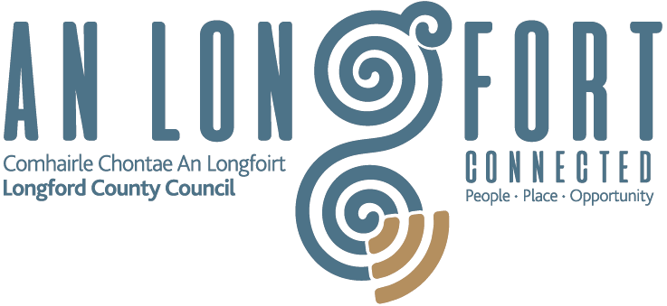
Outdoor Seating and Accessories for
Tourism and Hospitality Business Scheme

PART A - GENERAL TERMS AND CONDITIONS OF SCHEME

Scheme Overview
The focus of this scheme is to provide a level of financial support to tourism and hospitality businesses, in our town centres, to purchase or upgrade equipment to provide additional outdoor seating and, therefore, increase their outdoor dining capacity for the summer of 2021. This scheme will financially assist and support independent tourism and hospitality business owners to create outdoor dining experiences in a regulated and accessible manner. Funding under the scheme is only available to existing businesses.

The Outdoor Seating and Accessories for Tourism and Hospitality Business Scheme will be administered through Local Authorities and each local Authority has the right to use their discretion in regard to their process and the development of appropriate terms and conditions that are appropriate for their respective streetscapes, businesses etc. All applicants will be required to comply with planning codes, legislative requirements and other compliance requirements.

- Who is Eligible?
- The scheme is open to attractions, hotels, restaurants, cafes, public houses or other tourism and hospitality business establishments.
- Those premises that have no commercial rates outstanding to Longford County Council or have a payment plan in place.

- What Items are considered eligible for the scheme.
- Tables
- Chairs
- Umbrellas
- Electric heaters
- Screens/windbreaks
- Plant stands
- Wooden Platform

The tables and chairs or other furniture shall be of robust and stable construction to prevent movement in adverse weather conditions and be agreed with Longford County Council.

Screens/windbreakers must be agreed with Longford County Council and will be subject to the following conditions;

- Screens to be plain, coloured or neutral canvas type, not more than 1 metre high, spanning between or framed by simple metal type posts.
- Screens to be manufactured from flame/fire retardant material.
- Base plates or weighted bases to screening posts must not extend outside the licensed area.
- All screens, posts and bases must be demountable.
- Screens must be sufficiently robust to prevent overturning in adverse weather conditions.
- No advertising apart from the name of the premises to be used on the screens, without the permission of Longford County Council.

- Amount of Grant Available

The scheme will provide for up to 75% of the ex-VAT cost of equipment purchased/installed with a maximum allowable contribution of up to €4,000 per applicant.

- Privacy & Data Protection

Personal information collected by Longford County Council is done so in order for us to process your application. Legally we can process this information as it is necessary for us to comply with our statutory/legal obligations. The protection of your personal data is a key priority for the Council and your data will be processed in line with our privacy policy which is available at: https://bit.ly/3mEVkQ4 or hardcopy from our offices at Longford County Council, Great Water Street, Longford, N39 NH56 .

If you require further information regarding our Privacy Statement, you can contact us at dpo@longfordcoco.ie. Alternatively, you can write to: Data Protection Officer, Longford County Council, Great Water Street, Longford, N39 NH56 or call: 0433 341233

- Applications for Funding Timeline
The scheme is open from the 12/4/2021 for applications. Applicants will apply through their relevant Local Authority. The scheme will close on the 30/9/2021.
- Freedom of Information

Applicants should be aware that, under the Freedom of Information Act 2014, information provided by them in this Application may be liable to be disclosed. Applicants are asked to consider if any of the information provided by them in their Application should not be disclosed because of its confidentiality or commercial sensitivity. If Applicants consider that certain information is not to be disclosed because of its confidentiality or commercial sensitivity, Applicants must, when providing such information, clearly identify such information and specify the reasons for its confidentiality or commercial sensitivity. If Applicants do not identify information as confidential or commercial sensitive, it is liable to be released in response to a Freedom of Information request without further notice or consultation with the Applicant. Longford County Council will, where possible, consult with the Applicant about confidential or commercial sensitive information so identified before making a decision on a request received under Freedom of Information.

Completed application forms or questions relating to Section 254 licences should be sent to:

Patricia McWeeney
Longford County Council
Great Water Street,
Longford
N39 NH56

Telephone: 043 3343346
Or by email to: pmcweeney@longfordcoco.ie

Any further information requested on the Outdoor Seating and Accessories for Tourism and Hospitality Scheme please contact by email: pmcweeney@longfordcoco.ie

I have read and understand the terms and conditions of the ‘Outdoor Seating & Accessories for Tourism and Hospitality Business Scheme’.

Signed: ______________________ Date: _____________________ Tel: _______________

Email: _______________________ Signature in Capital Letters: ____________________

Please see Part B - APPLICATION FORM AND PAYMENT DETAILS

Outdoor Seating and Accessories for Tourism and Hospitality Business Scheme

Part B - APPLICATION FORM AND PAYMENT DETAILS

All applicants will be required to comply with planning codes, legislative requirements, and other compliance requirements.

I hereby submit my application for a grant under Longford County Council’s Outdoor Seating and Accessories for Tourism and Hospitality Business Scheme 2021 for:

A) New outdoor seating & Accessories for Tourism and Hospitality – I have applied for a Section 254 licence
B) New/replacement outdoor seating and accessories permitted under an existing Section 254 licence
Please supply relevant licence reference no.: ______________________

C) New outdoor seating & accessories for tourism and hospitality for use within my own business premises – no Section 254 licence is required

D) Grants provided under this scheme are classed as De Minimis State Aid. There is a ceiling of €200,000 for all De Minimis aid regardless of the source, given to any one enterprise or group by any state agency or public body over the last 3 years. For more information read Chapter 3 of Fáilte Ireland’s State Aid Handbook: bit.ly/32S6fww

I hereby declare that my enterprise has not received any De Minimis aid or an amount greater that €195,000 in the last 3 years.

New Supplier Set-Up/Direct Payment Authorisation

SUPPLIER NAME: __________________________________________________

BUSINESS NAME: __________________________________________________

SUPPLIER ADDRESS: __________________________________________________

PPS No/Tax Reference No: _________________________________________________

TELEPHONE and FAX NO: __________________________________________________

EMAIL: __________________________________________________
(Details of the amount transferred to your bank Account will be sent to this address)

CURRENCY: __________________________________________________

I hereby request Longford County Council to transfer payments to:

BANK NAME: __________________________________________________

BANK ADDRESS: __________________________________________________

ACCOUNT NAME: __________________________________________________

ACCOUNT NO: __________________________________________________

BANK SORT CODE: __________________________________________________

IBAN NUMBER: __________________________________________________

BIC CODE: __________________________________________________

SIGNED: __________________________________________________
(Please return in hardcopy with original signature)

DATE: __________________________________________________

